DATES FOR BAPTISM PREPARATION
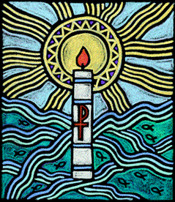September 2017—August 2018
Preparing for your child’s Baptism
at
SS. Joseph
and
St Swithun’s
Catholic Church
Bromley
1 Orchard Road,
Bromley, BR1 2PR 020 8402 0459
admin@stjosephsbromley.org www.stjosephsbromley.org
Preparation Sessions Sunday  after 9.15am Mass  or  3.45pm before  5pm Mass | Rite of Welcome during Sunday Mass 9.15am or 5pm | Baptism Sundays 1st Sunday of the Month  11am or 5pm Mass – or 2pm afternoon
3/10/17/24  September  9.15am | 17 September 9.15am | 1 October
1/8/15/22 October  3.45pm | 15 October  5pm | 5 November
5/12/19/26  November  3.45pm | 19 November  5pm | 3 December
7/14/21*/28*  January 2017  9.15am | 21 January  9.15am | 4 February
4*/11/18/25*  February  9.15am | 18 February  9.15am | 1 April  Easter Sunday
8/15/22/29  April  9.15am | 22 April  9.15am | 6 May
6/13/20/27  May  3.45pm | 20 May  5pm | 3 June
3/10/17/24 June  9.15am | 17 June  9.15am | 1 July
1/8/15/22 July  9.15am | 15 July  9.15am | 5 August
5/12/19/26 August  9.15am | 19 August  9.15am | 2 September
asterisks* indicate sessions in Skip Appleton Room
We want your child's baptism to be a time of joy and celebration for you and the whole parish community. Naturally, you want the best for your child, and we do too.

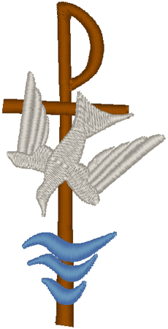
"Parents you have asked to have your children baptised.
In doing so you are accepting the responsibility
of bringing them up in the knowledge and love of God and in the practice of the faith."
RITE OF BAPTISM

Preparing for baptism:
If you are a practising Catholic and want to celebrate the
Sacrament of Baptism please contact one of the priests during a Surgery Time* in St. Joseph's Presbytery and ask for an application form.
You will then be enrolled for the next available baptism preparation course. Baptism preparation takes place nine times a year.

"The Christian Community welcomes you with great joy"

RITE OF BAPTISM

Godparents: Support you and your child on your journey of faith. This means that the Godparents you choose for your child should be practising Catholics who have been Confirmed and are over the age of 16.

Christian Marriage:
For parents who are not already married, or not married in the Catholic Church, a meeting with the priest to discuss your marital status is essential prior to enrolling. A session with the priest to discuss, and consider, the value of Christian marriage is also a necessary requirement.

*Times of Surgery can be found on the parish newsletter
The shape of our baptism course:

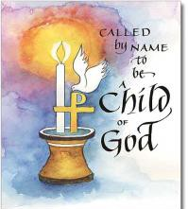
Preparing Together

You will take part in a series of 4 sessions leading to the Celebration of Baptism.
Session 1: Introduction – the offer of a House Blessing

Session 2: A tour of the Church and the importance of Welcome and the Role of Godparents
Session 3: What We Believe we are passing on to our children
Session 4: The Ritual and Symbols of Baptism
Session will begin after 9.15am Mass on Sunday Morning or at 3.45pm on
a Sunday afternoon followed by the celebration of Sunday Mass at 5pm

Rite of Welcome in Church
Your child and your family are welcomed at 9.15am Mass before session 3 or at 5pm Mass after session 3 by the whole Christian community.
Your child is signed with the sign of the cross and anointed

We Celebrate Baptism in Church

We gather with all of God's People at the Sunday Eucharist to celebrate the Baptism of your child into our community

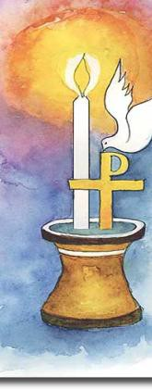
"As you have been enlightened by Christ, so may you always walk as children of light.
May you keep the flame of faith
alive."
RITE OF BAPTISM

